Workshop
ON
“Bioethics Andragogy for Future Generation of Doctors”
BY
CENTRE OF EXCELLENCE FOR ANDRAGOGICAL AND PEDAGOGICAL SCIENCES(CEAPS)
&
UNESCO BIOETHICS UNIT
ON
23rd and 24th November 2023

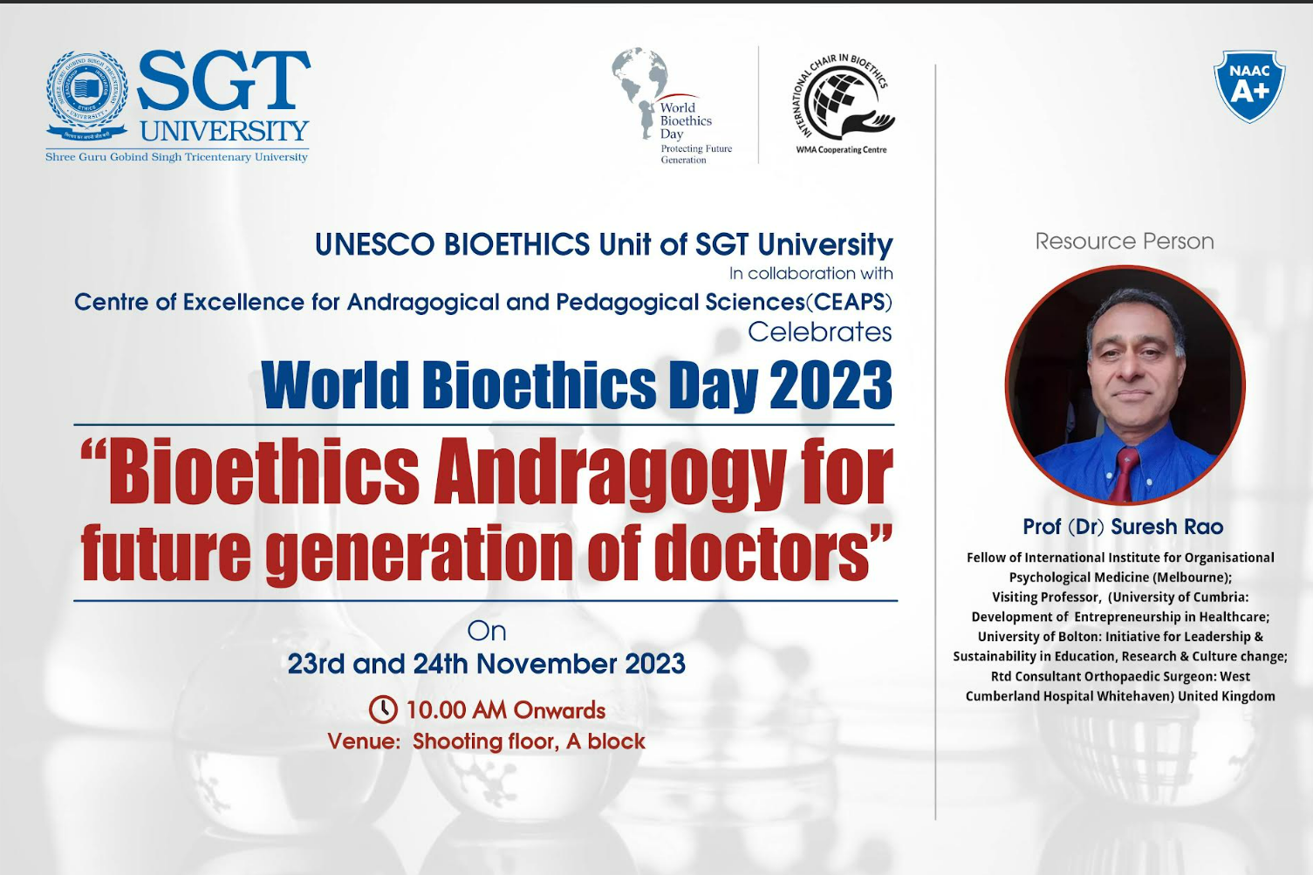

Workshop
ON
“Bioethics Andragogy for Future Generation of Doctors”

For celebration of

WORLD BIOETHICS DAY 2023
BY
UNESCO BIOETHICS UNIT
&
CENTRE OF EXCELLENCE FOR ANDRAGOGICAL AND PEDAGOGICAL SCIENCES(CEAPS)

ON
23rd and 24th November 2023
At Shooting floor, A block

Brief Profile of Speakers:
1) Prof Suresh Rao, Visiting Professor, Institute of Health
Academic Quality and Development, Enterprise and Business Development
Initiative for Leadership and Sustainability, Learning, Education &amp; Development
Research Centre, University of Cumbria, England, United Kingdom
Consultant Orthopaedic &amp; Trauma Surgeon at West Cumberland Hospital,
Carlisle, England, United Kingdom
2) Prof Guriqbal Singh Jayia, AIIMS
3) Prof Manoj Kumar Singh, Professor, Anatomy, AIIMS

Organizers:

UNESCO Bioethics Unit, SGT University and CENTRE OF EXCELLENCE FOR ANDRAGOGICAL AND PEDAGOGICAL SCIENCES(CEAPS)

Report of the Webinar/ Event / FDP Program:

The UNESCO Bioethics Unit, in collaboration with the Centre of Excellence for Andragogical and Pedagogical Sciences (CEAPS), successfully conducted a two-day workshop titled “Bioethics Andragogy for Future Generation of Doctors” on the 23rd and 24th of November 2023, as part of the World Bioethics Day 2023 celebrations.
The workshop was led by Prof. Suresh Rao from North Cumbria University, UK, an esteemed international resource person. Supporting him were 2-3 colleagues from AIIMS, who contributed their expertise to facilitate various sessions.

Workshop Overview
Day 1: November 23, 2023
- Participants: The workshop saw active participation from faculty members of various disciplines, including Medical Sciences, Dental Sciences, Physiotherapy, Ayurveda, Pharmacy, Nursing, Naturopathy, Allied Health Sciences, and Behavioral Sciences.
- Timings: 10:00 AM - 4:00 PM
- Format: A full-day workshop with a Team-Based Learning (TBL) approach, engaging 60-80 participants to ensure focused interaction and in-depth discussions.
- Sessions:
  - Participants were introduced to strategic theme-based action planning using an andragogical approach to integrate bioethical principles into their teaching and practice.
  - The sessions emphasized practical implementation techniques, empowering the faculty to adopt innovative methods for imparting bioethical education.
- Venue: Shooting Floor, A Block
Day 2: November 24, 2023
- Participants: The second day focused on final-year students and interns from medical and allied disciplines, with 60-80 students in attendance.
- Timings: 10:00 AM - 1:00 PM
- Format: A half-day workshop utilizing a team-based learning approach to facilitate student engagement.
- Sessions:
  - Students explored key bioethical dilemmas through interactive discussions and practical case studies.
  - The workshop encouraged critical thinking and awareness of ethical considerations in healthcare practices.
  - The day concluded with the felicitation of winners from the Bioethics Day International Competitions 2022 and the Internal Bioethics Day Competitions 2023.
- Venue: Shooting Floor, A Block
Outcomes
The workshop successfully:
- Enhanced the understanding of bioethics among faculty and students, equipping them with actionable knowledge and strategies.
- Fostered a deeper appreciation for ethical decision-making in healthcare education and practice.
- Promoted interactive and collaborative learning experiences through the integration of innovative andragogical methodologies.
This event served as a significant step towards cultivating ethical and socially responsible practices in healthcare, reinforcing the commitment of SGT University to nurturing future-ready professionals.

Detailed Minute to Minute Schedule for 23rd November

S.No | Timing | Event | Venue | Particulars
1 | 9:30-10:15 am | Guest Reception and Interaction with University officials | VC Office, A Block | Vice Chancellor Sir, PVC Sir, Dean Academics, Convenor CEAPS
2 | 10:15 am | General Welcome | Shooting Floor, A block | Ms Arvinder Kaur Pabla, Master of Ceremony
3 | 10:20 am | Lamp Lighting |  | Guests and University Dignitaries
4 | 10:25am | Felicitation of Guests |  | Prof Suresh Rao- Vice Chancellor Sir & Registrar Sir  Prof Manoj Kumar Singh- Pro Vice Chancellor Sir & Dean Academics  Prof Guriqbal Singh Jaiya- Director, Approval and Recognition & Convenor, CEAPS
5 | 10:30 am | Welcome Address by Vice- Chancellor |  | Prof OP Kalra, Vice Chancellor
6 | 10:35am | Introduction of Resource person and Facilitators |  | Ms Arvinder Kaur Pabla, Master of Ceremony
7 | 10:40 am | Introduction to the sessions |  | Prof Suresh Rao, Visiting Professor, University of Cumbria, UK
8 | 11:00-11:15am | Tea Break
9 | 11:15-11:45am | Session 1: Hands on (Leadership Exercise) |  | Prof Suresh Rao  Prof Manoj Kumar Singh
10 | 11.45- 12:20pm | Session 2: ‘Inspirational Case studies’: (Small Group Discussion) |  | Prof Suresh Rao  Prof Manoj Kumar Singh  Prof Guriqbal Singh Jaiya
11 | 12:20-1:00pm | Session 3: ‘Dilemmas in Bioethics’ (Focus Group Discussion) |  | Prof Suresh Rao  Prof Manoj Kumar Singh  Prof Guriqbal Singh Jaiya
12 | 1:00-1:30pm | Lunch Break | Ambrosia, 2nd Floor, A block | Guests and University Officials
13 | 1:30- 2:00pm | Summary of Feedback from Sessions 1-3 (Moderators & Facilitators) | Shooting Floor, A block | Prof Suresh Rao
14 | 2:00-2:30pm | Session 4: Thematic Strategy: Dashboard of Programmes, Project Gantt Charts & Action Planning |  | Large Group Discussion session led by Suresh Rao
15 | 2:30-3:30pm | Session 5: Creating Teams & Collaborative Groups |  | Focus Group Discussions facilitated by Prof Suresh Rao and moderators
16 | 3:30-3:45pm | Feedback from Facilitators of each group |  | Large Group Discussion
17 | 3:45-3:55pm | Concluding Session |  | Prof Suresh Rao and Moderators
18 | 3:55pm | Vote of Thanks |  | Prof Astha Chaudhry, Secretary Bioethics Unit and Convenor CEAPS

24th November : Andragogy sessions for final year students
0930 Briefing session with faculty ‘role of Moderators & Facilitators’ in adult learning
1000-1045 Session 1 Suresh Rao: Theme-based large group Discussion on
‘How we almost went extinct - several times!’ (Videos circulated previously)
Learning to Walk properly – before running! (‘Walking Grand Rounds’: Exercise)
1045-1100 Session 2: Break-out groups led by the ‘Facilitators’ & ‘Moderators’ (one each for every group for Discussion:
Discussion points are:
How is our ‘modern’ lifestyle a curse not a boon?
How did our ‘grandmother’ culture save us from extinction?
How does culture impact upon health care?
Do doctors and nurses have a duty to society?
How could future generations learn from the mistakes of our generation?
Highlights of Day 1

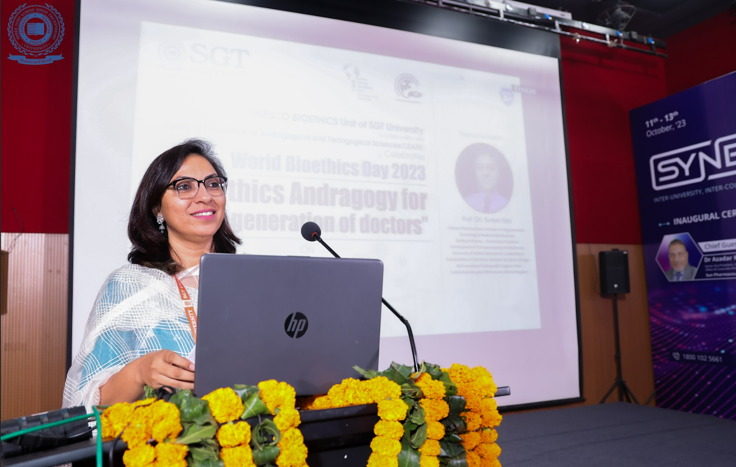
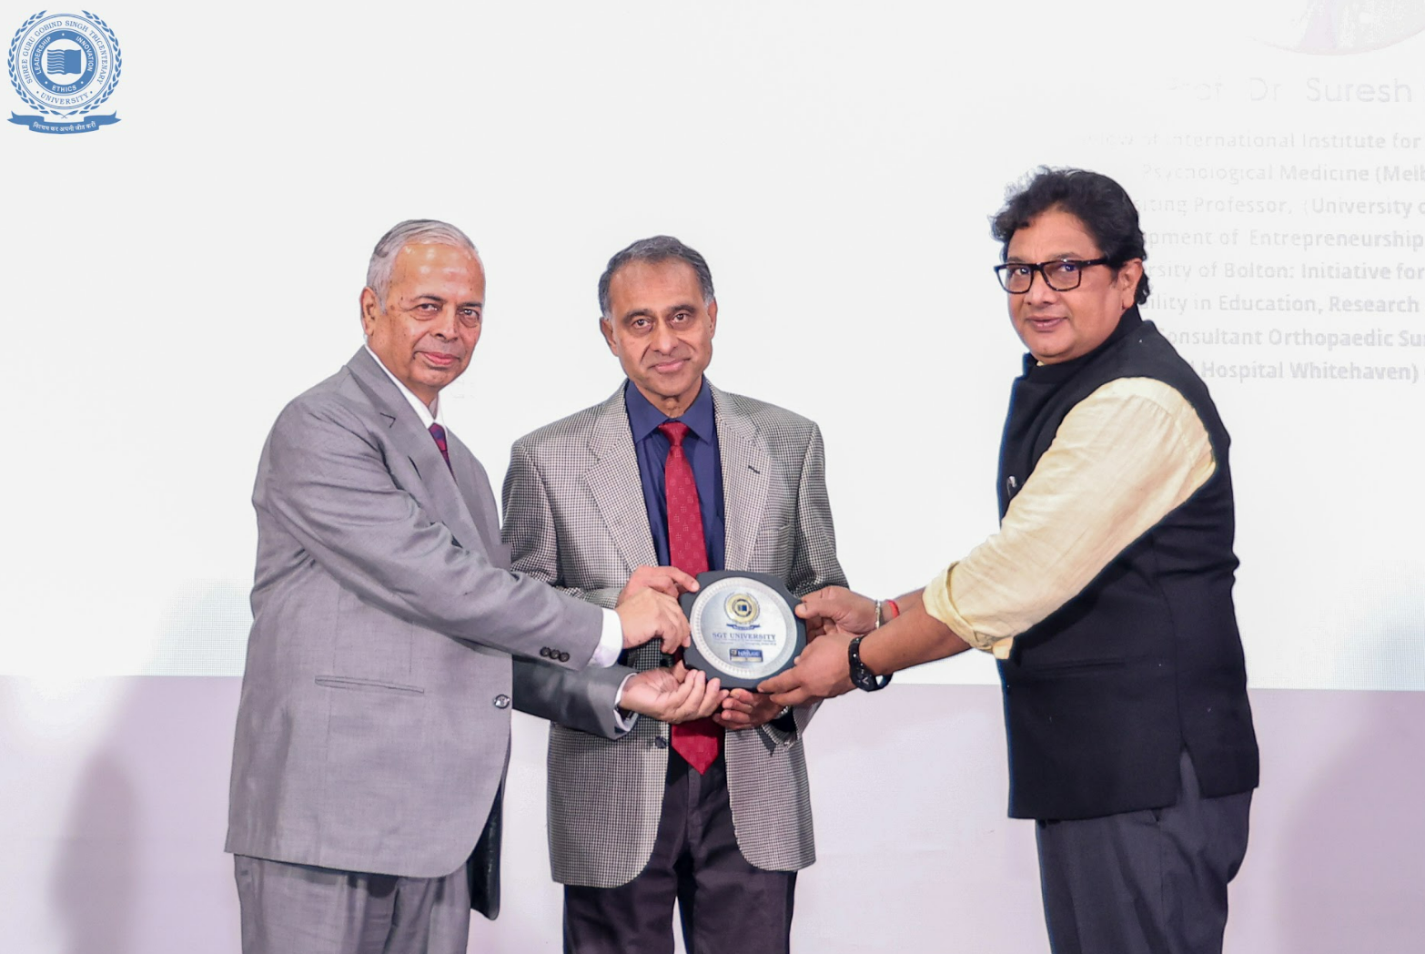
Felicitation of Prof Suresh Rao by Prof OP Kalra, Vice Chancellor and Prof Jogender Yadav, Registrar, SGT University
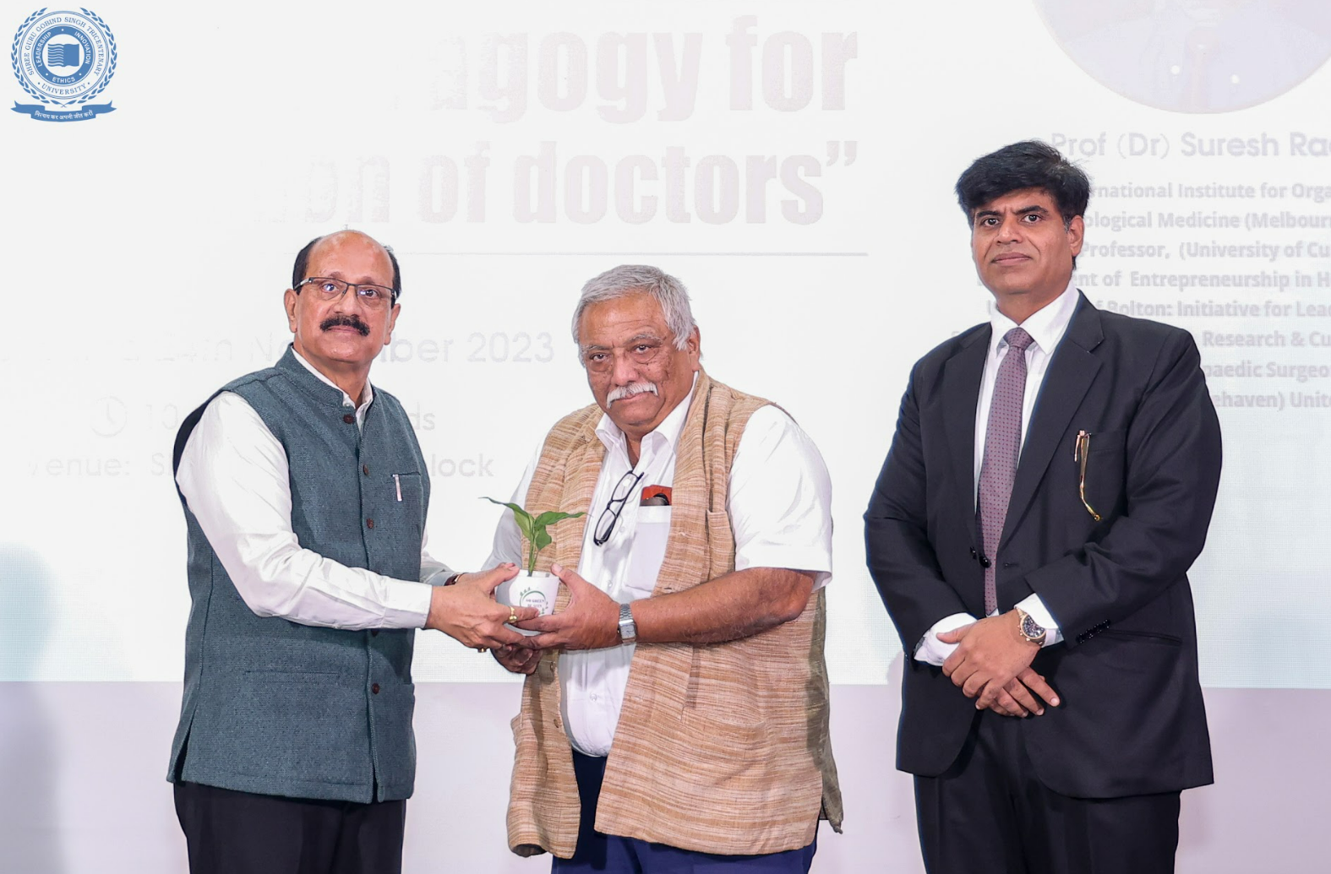
Felicitation of Prof Manoj Kumar Singh by Prof Atul Nasa and Prof Vikas Dhawan, PVC, SGTU
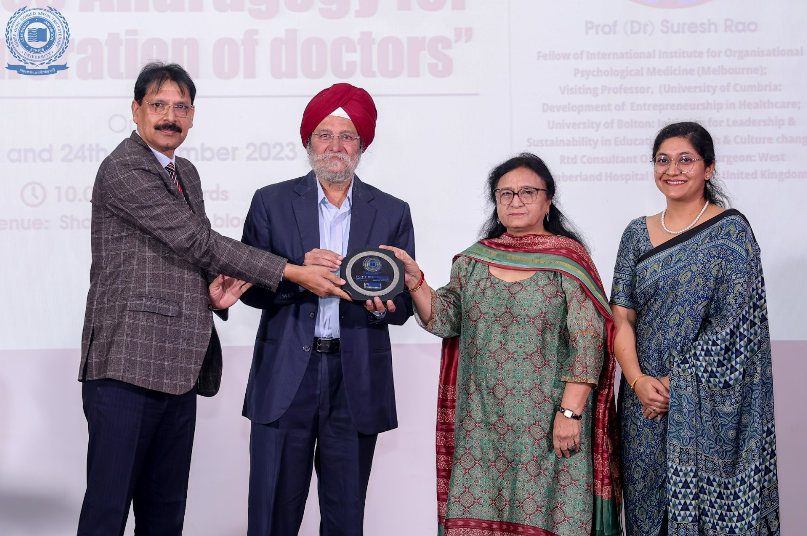
Felicitation of Prof Guriqbal Singh Jayia by Prof Waheeda Khan, Advisor, Prof Satish Chander Sharma, Director, IQAC and Dr Astha Chaudhry, Convenor, CEAPS

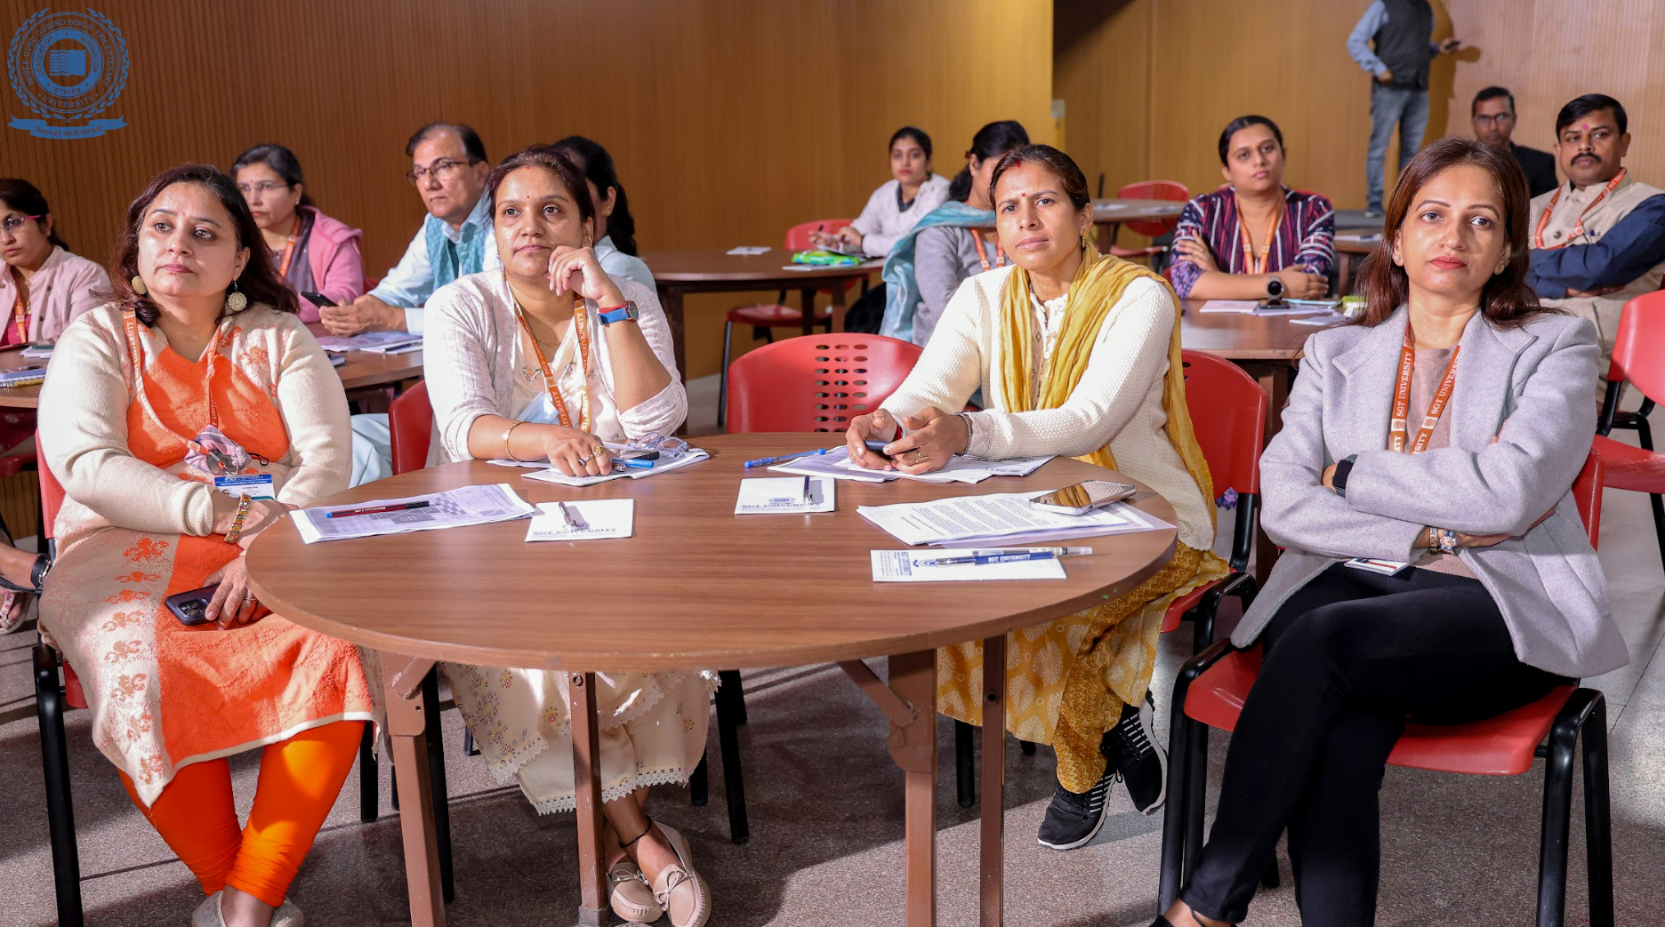

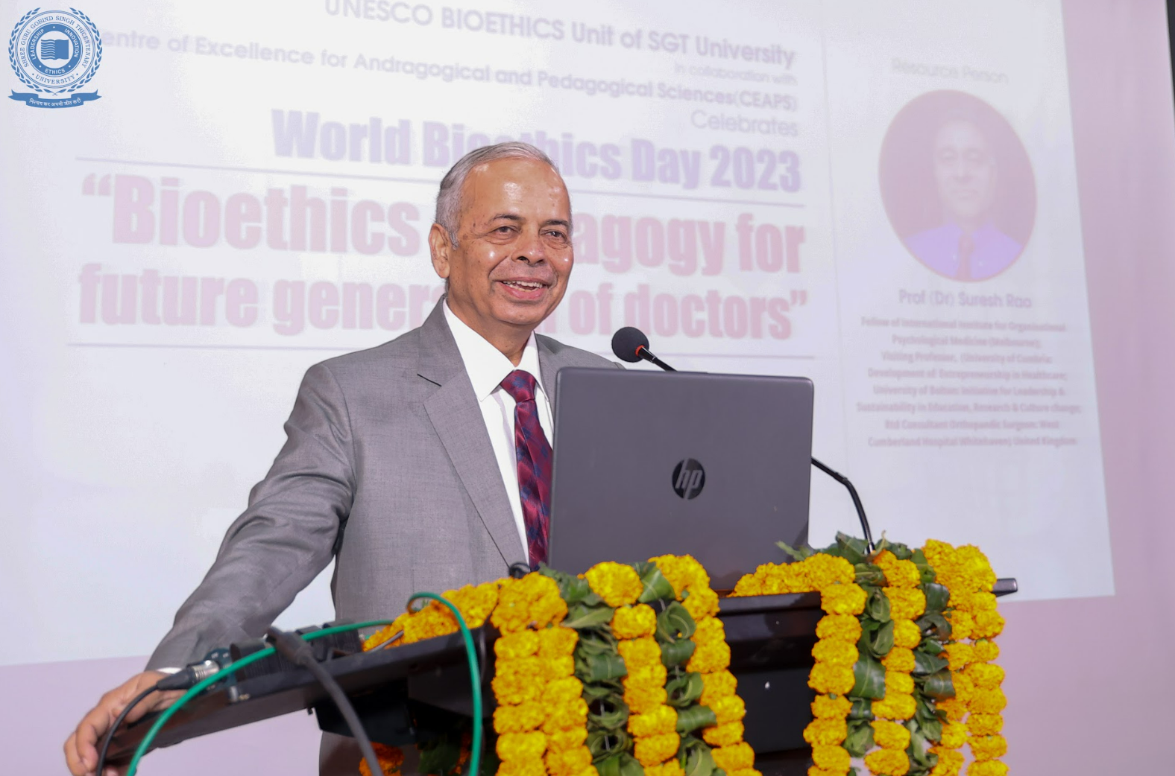
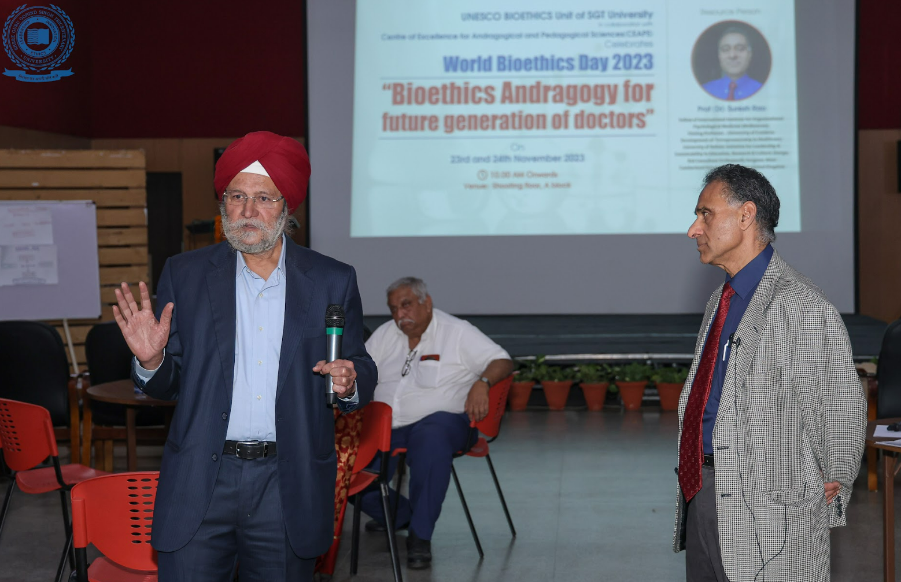
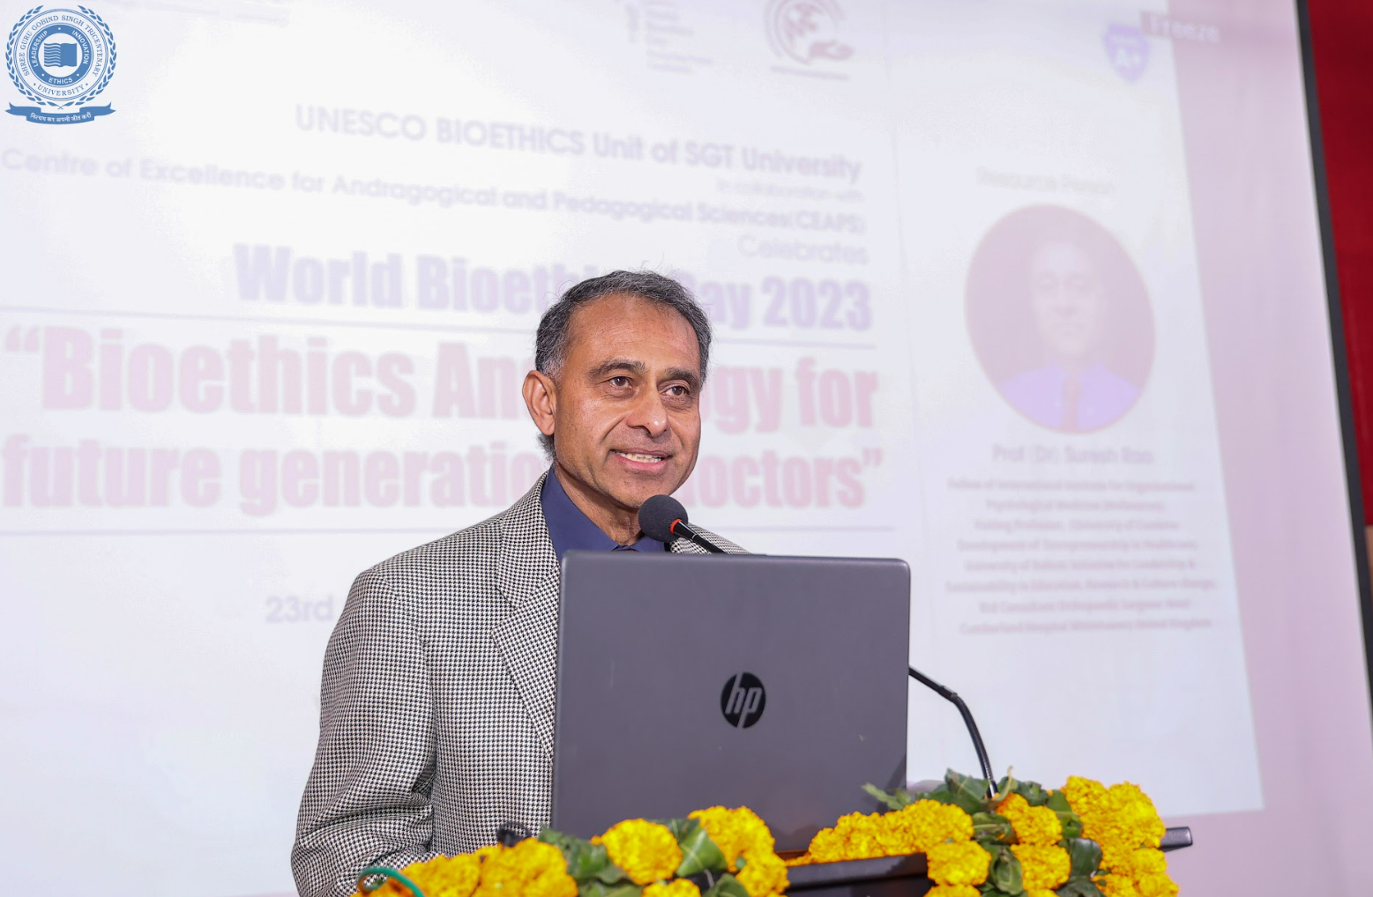
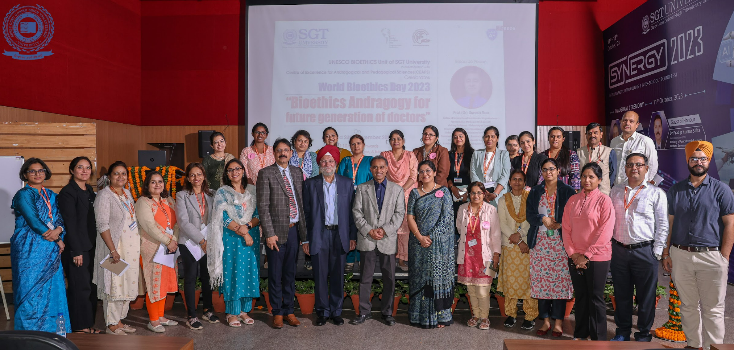

Highlights of day 2
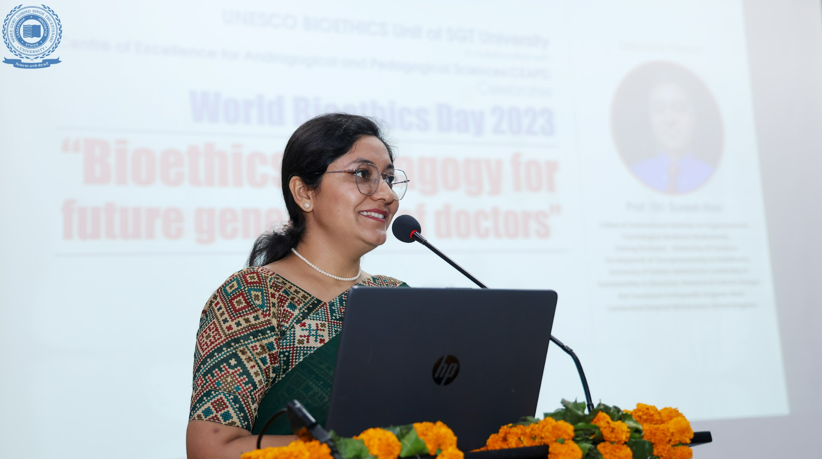

Presentation of World Bioethics Day 2022 and 2023 report and felicitation of students whose entries were selected for international competitions. 2 entries received International awards from International Chair in Bioethics at Haifa, Israel.
The following is the list of winners for International World Bioethics Day competitions 2022, out of which SGT University bagged two awards in the category of short film and artistic poster. The winners as well as participants of competitiosn were awarded certificates and trophies.
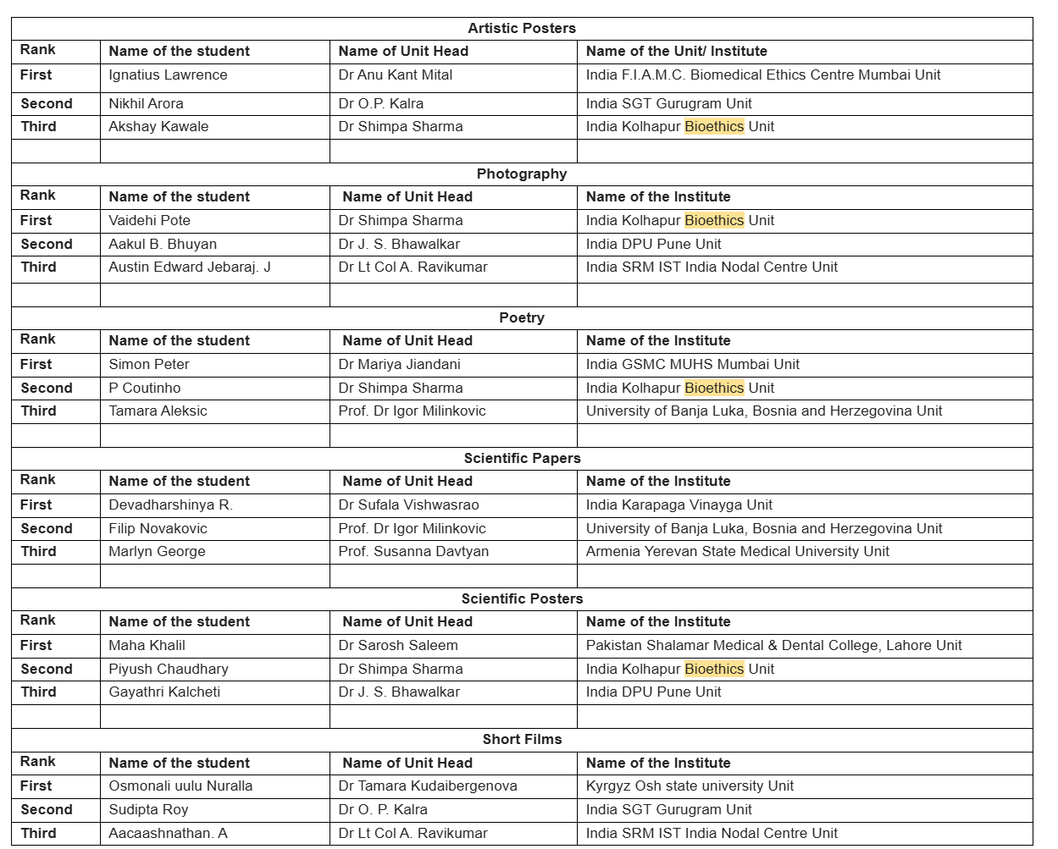

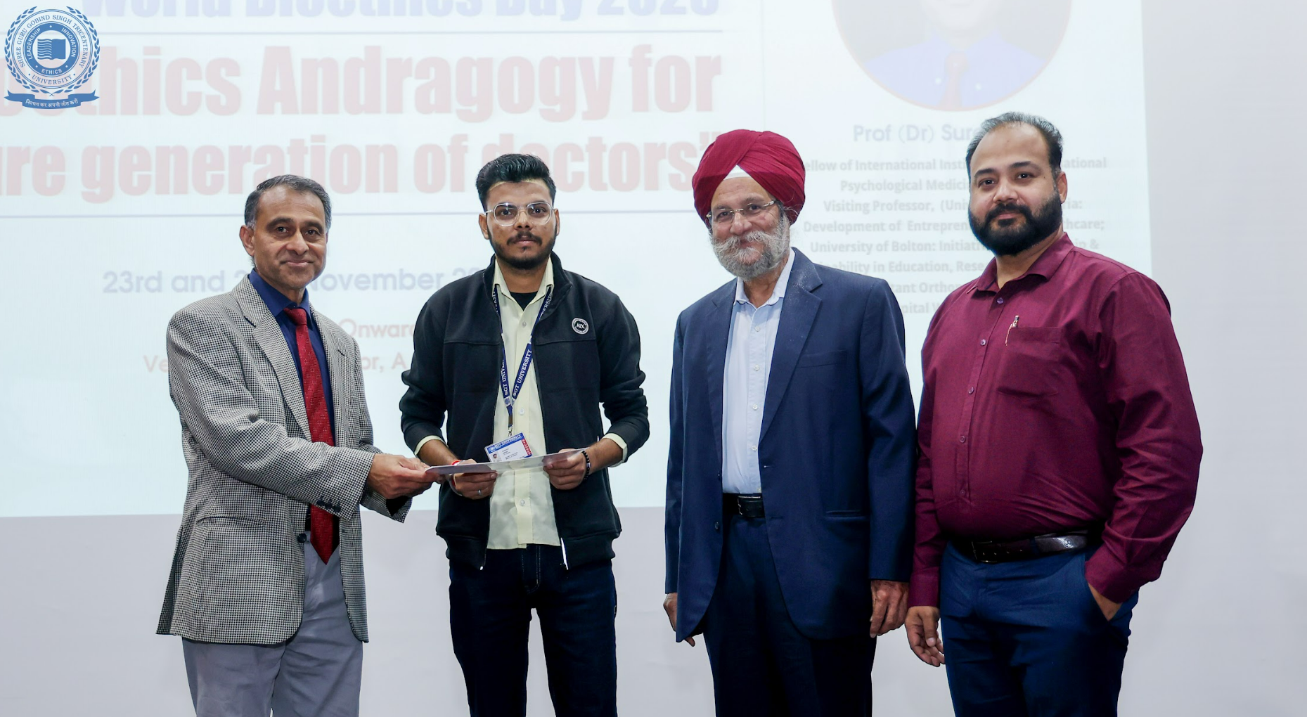

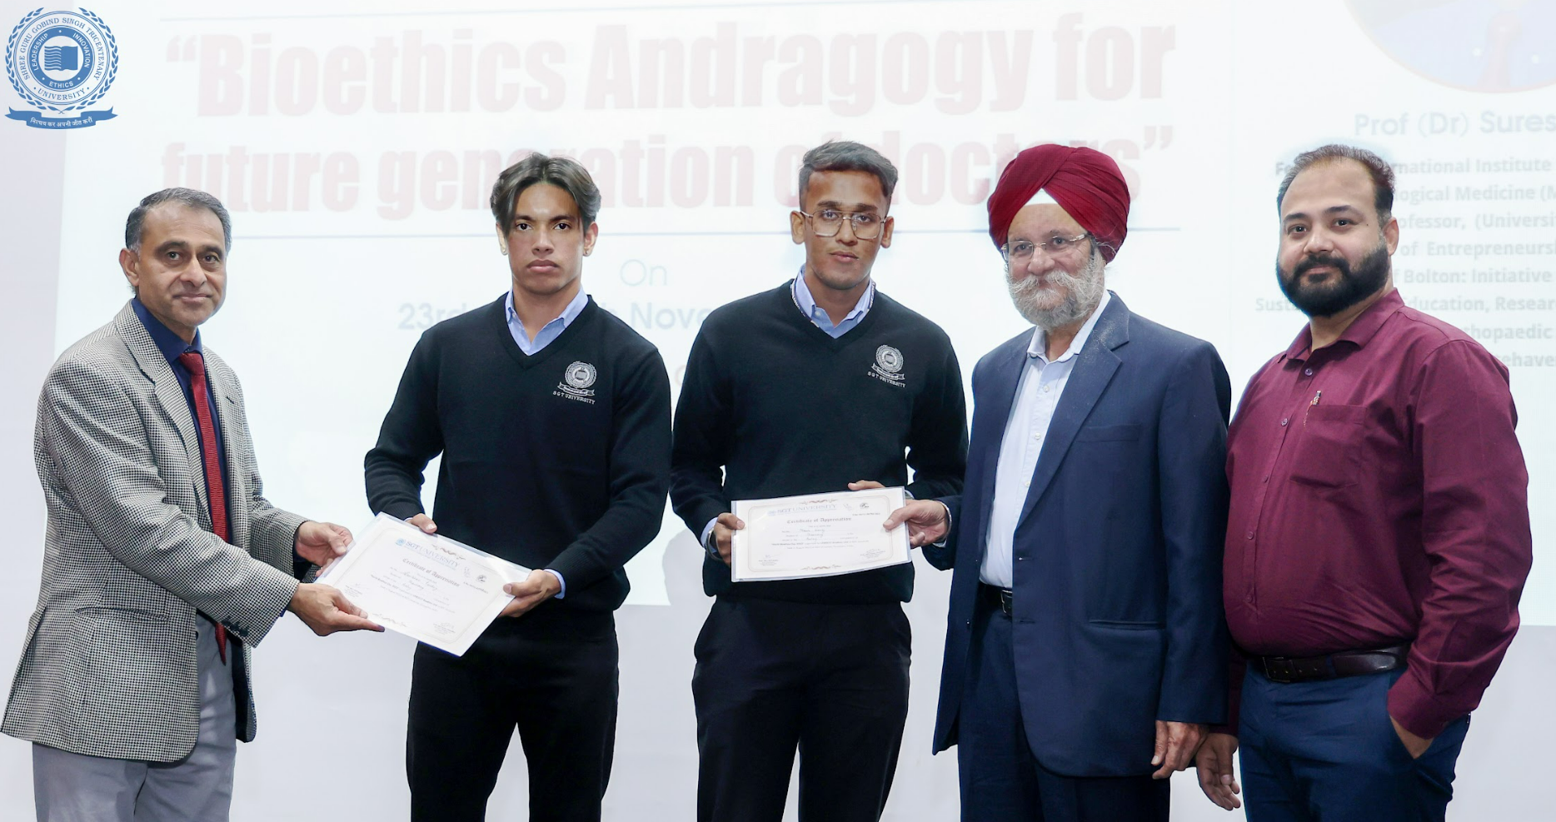
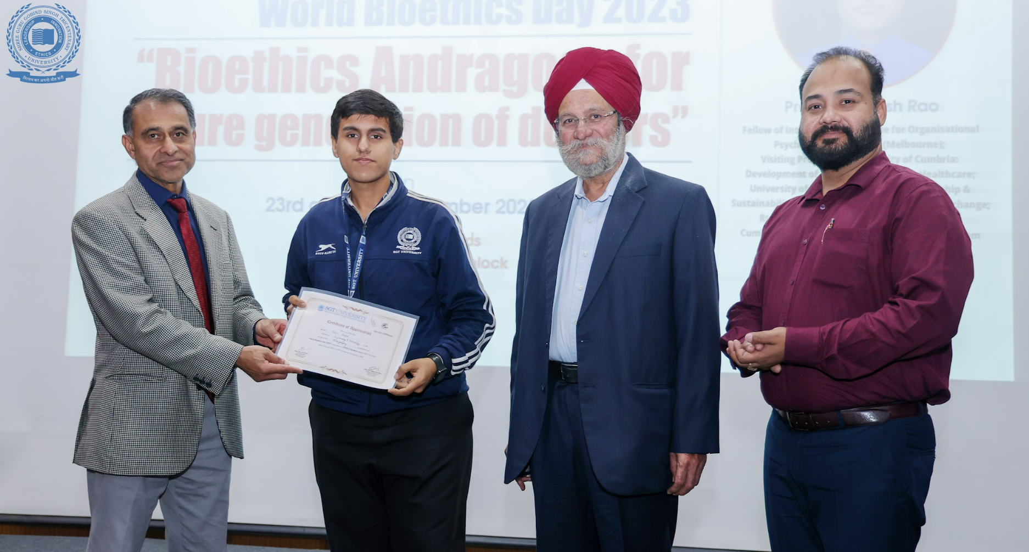
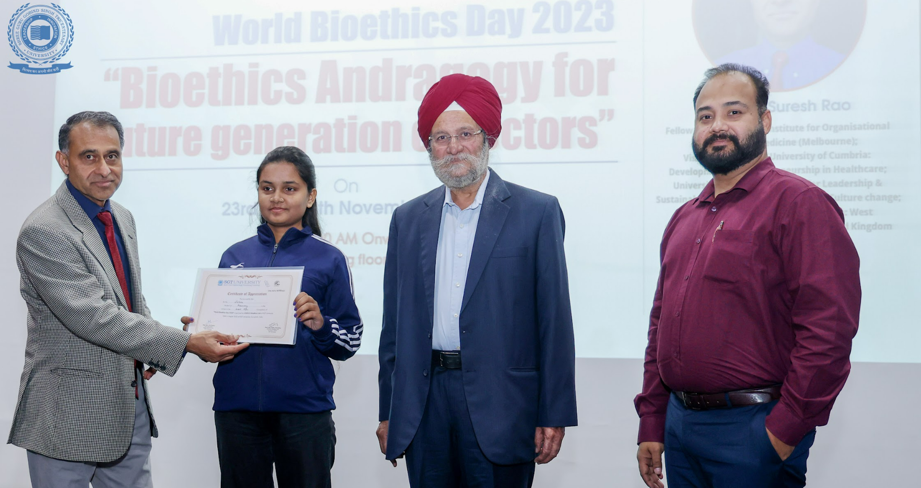
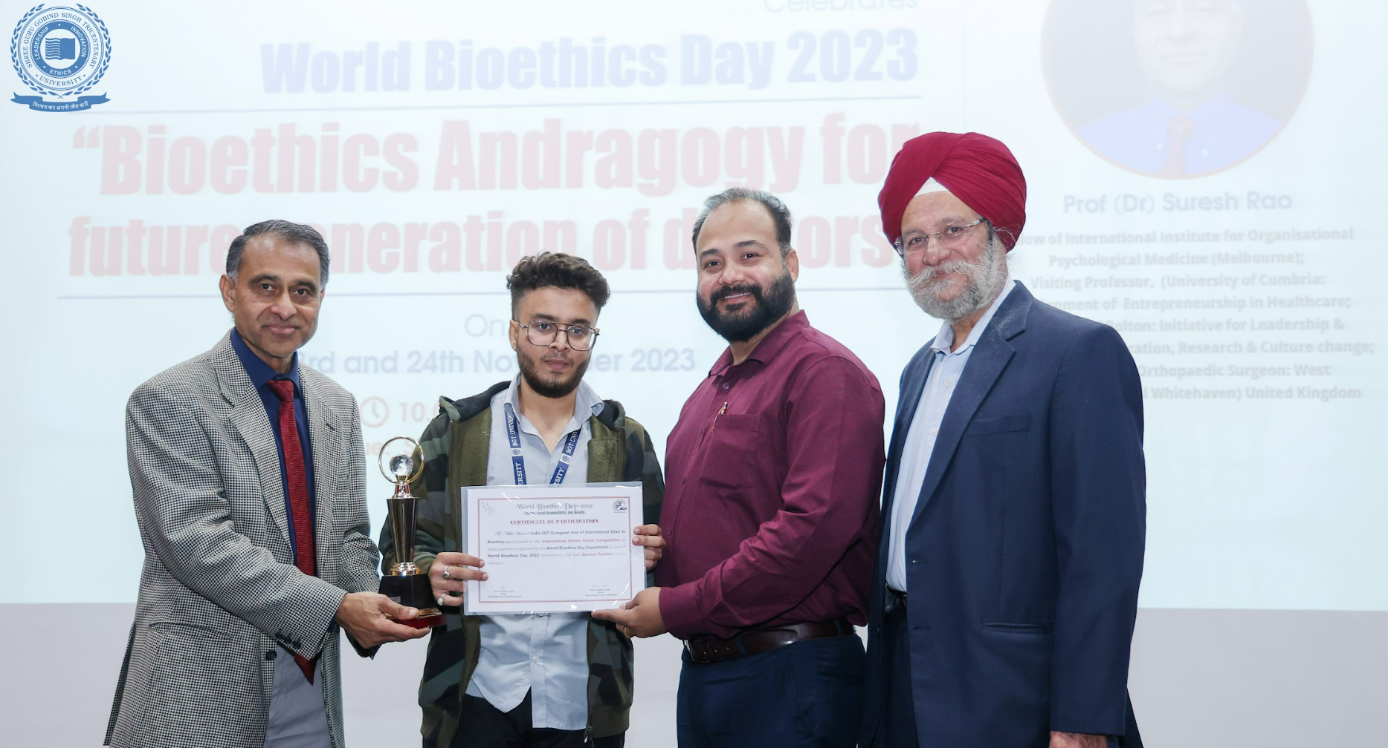
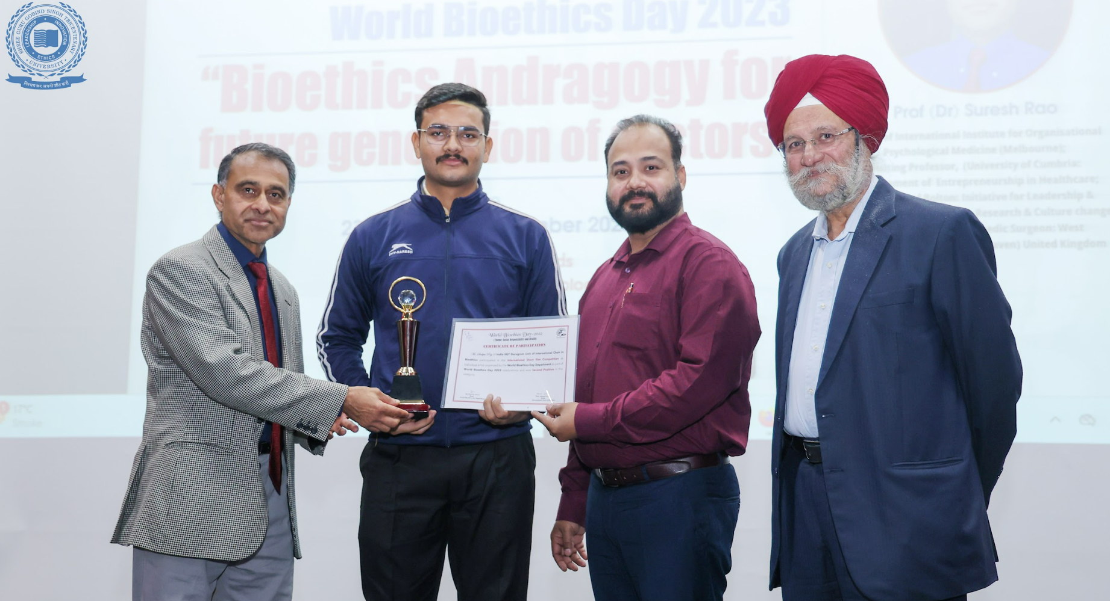
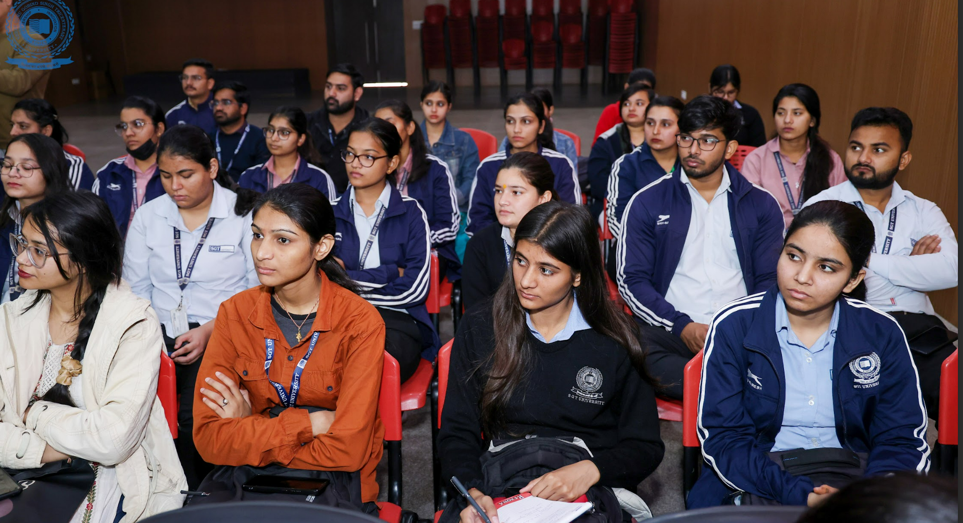
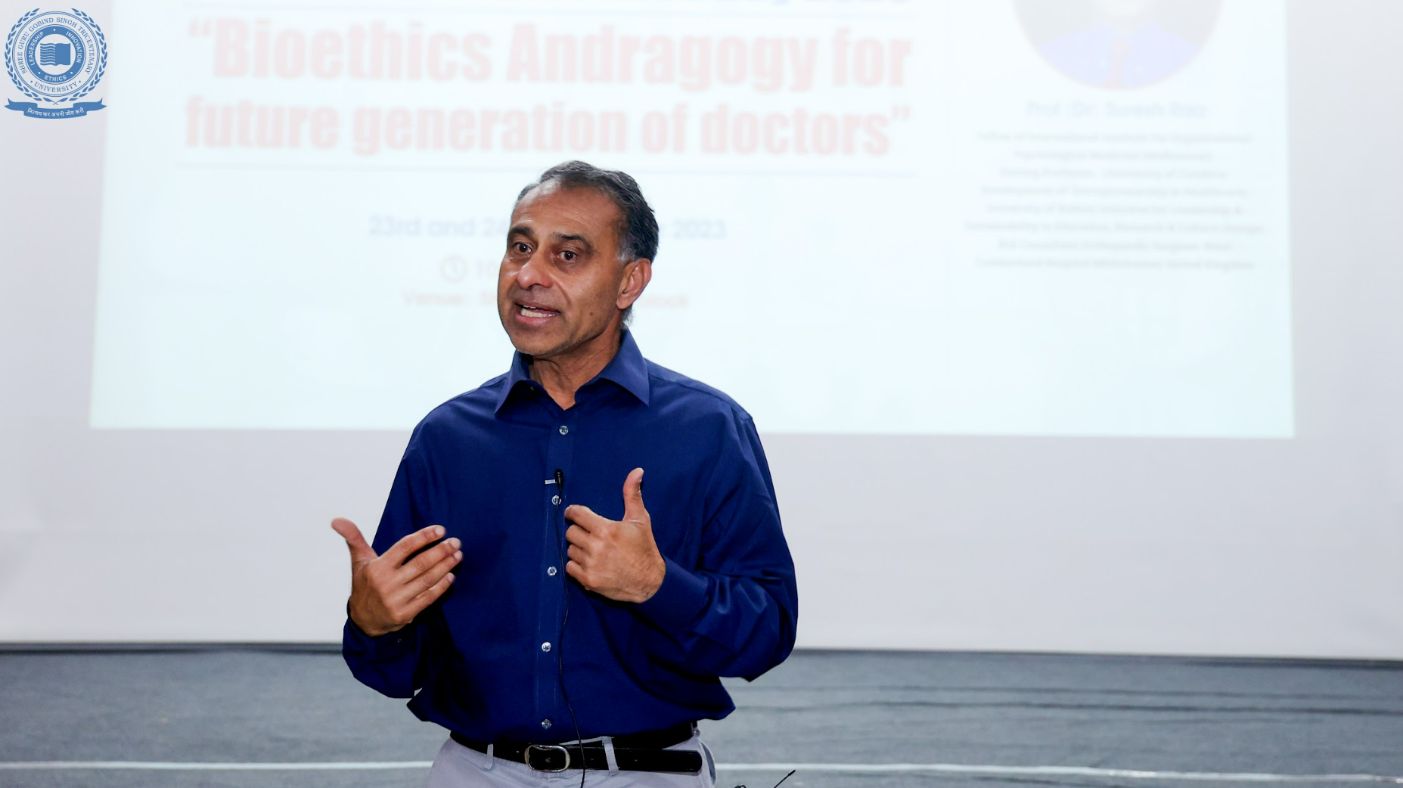

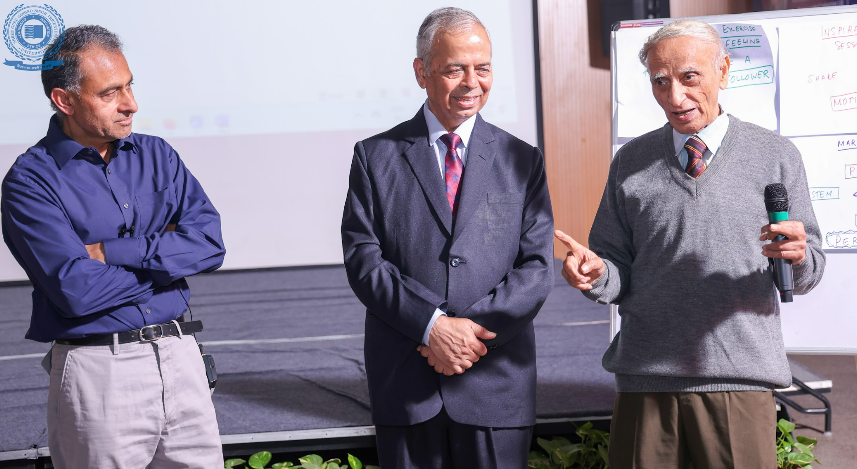

The event also witnessed the gracious presence of Prof Sujoy Guha, an eminent researcher and Padmashree Awardee who is continuing his research project at SGT University.

The nominations for the workshop were sought from Deans for faculty as well as students. The following is the mail sent to Deans for nominations for the CBP:

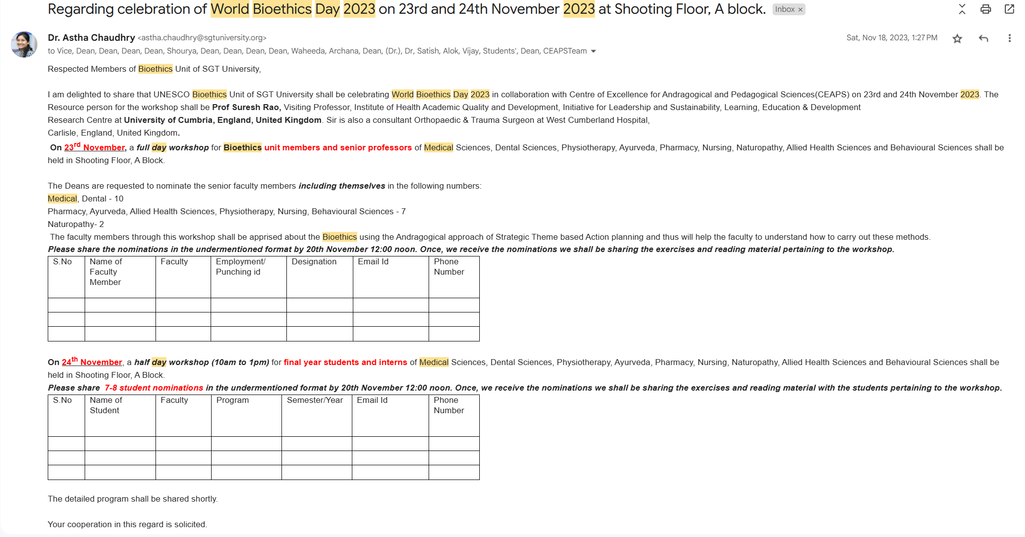

The learning material from the resource person was also shared with all students and faculty.

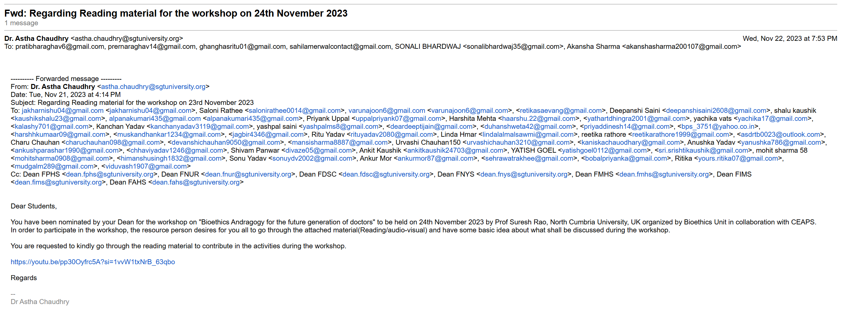
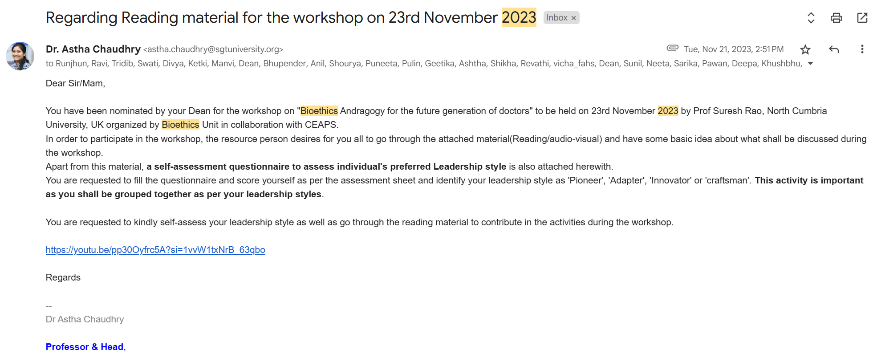

On 24th November- the winners of the World Bioethics day 2022 were felicitated:
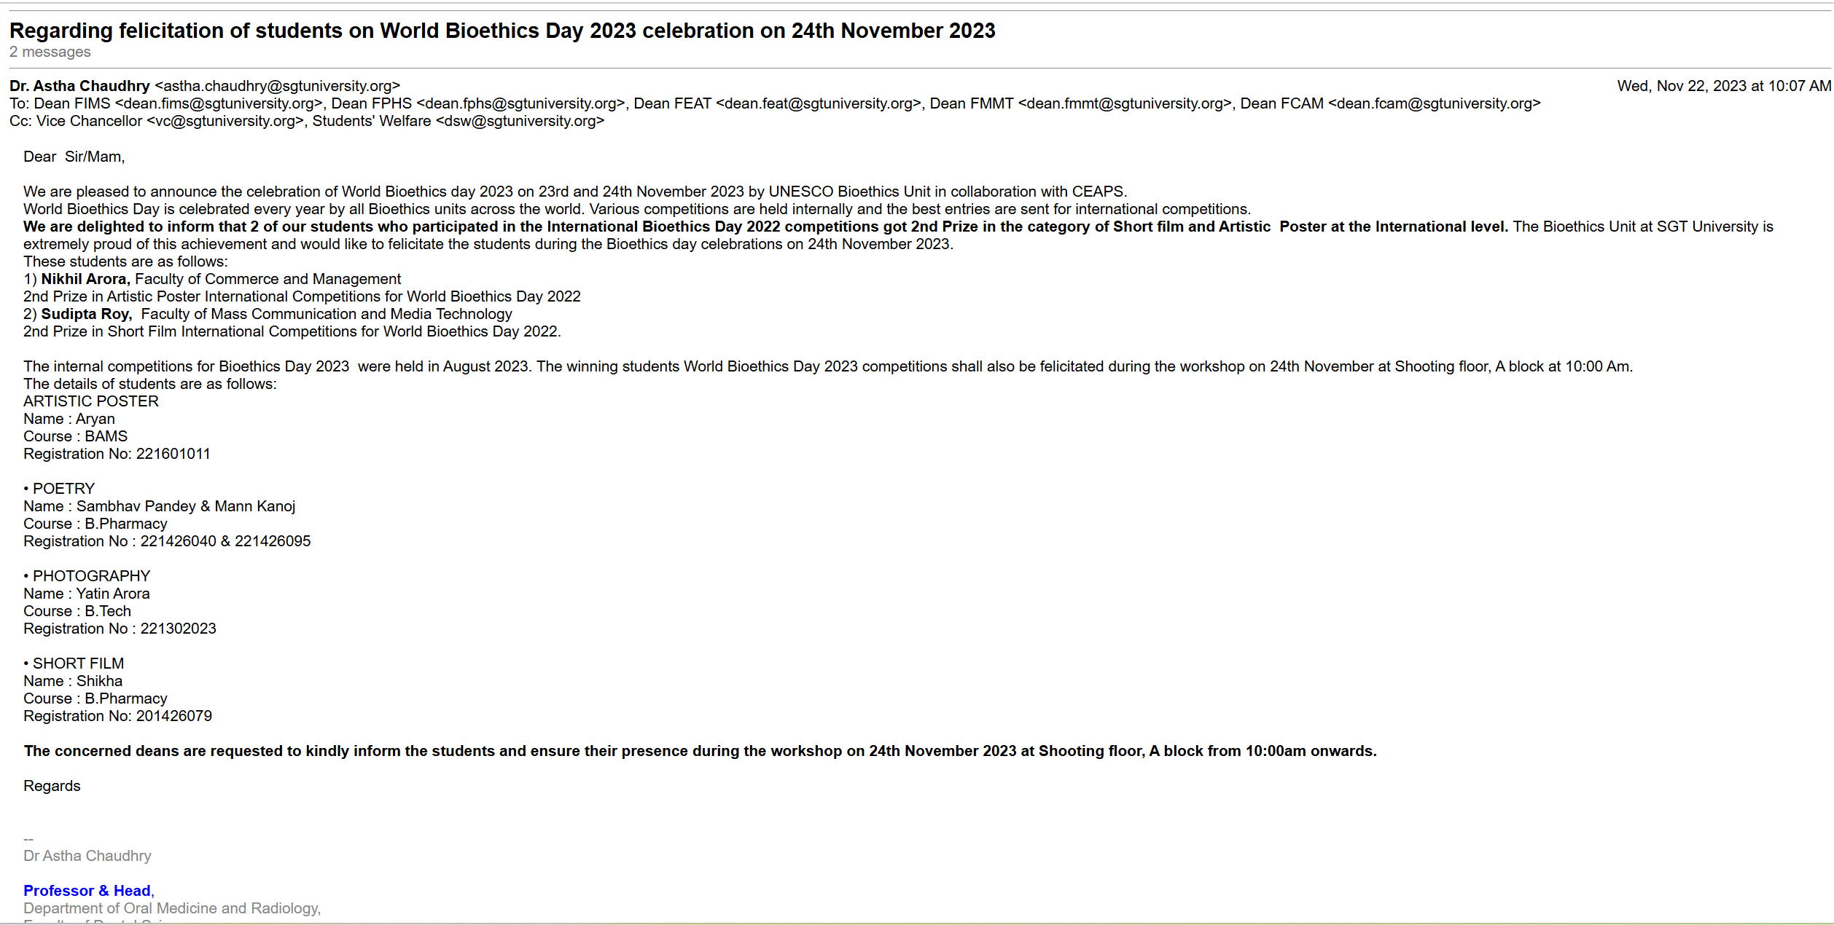

The following is the List of Participants for 23rd November 2023:
S.NO | NAME OF FACULTY MEMBER | Designation | EMPD ID | EMAIL ID
1 | Dr Sunil Kumar Dular | Dean | 141 | skdular@sgtuniversity.org
2 | Dr Neeta Bhide | Professor Cum Hod | 20500 | neeta_fnur@sgtuniversity.org
3 | Mrs. Sarika Yadav | Professor Cum Hod | 204 | sarika@sgtuniversity.org
4 | Dr Pawan | Professor Cum Hod | 20884 | pawan_fnur@sgtuniversity.org
5 | Ms Deepa Mukherjee | Associate Professor | 18860 | deepa_fnur@sgtuniversity.org
6 | Dr Khushbu | Associate Professor | 267 | khushbhu.nursing@sgtuniversity.org
7 | Ms Rajwant Kaur | Associate Professor | 20984 | rajwant_fnur@sgtuniversity.org
8 | Dr. Jyoti Kumbar | Professor | 1648 | jyoti.fims@sgtuniversity.org
9 | Dr. Anupama Patra | Professor | 1491 | anupama.fims@sgtuniversity.org
10 | Dr. Rekha Phull | Professor | 1408 | rekha_fims@sgtuniversity.org
11 | Dr. Anupam Sharma | Professor | 1517 | anupam@sgtuniversity.org
12 | Dr. Bharat Vats | Associate Professor | 18780 | bharatvats_fims@sgtuniversity.org
13 | Dr. Milind Deshmukh | Associate Professor | 1519 | milind_fims@sgtuniversity.org
14 | Dr M Ejaz Hussain | Professor | 19164 | dean.fahs@sgtuniversity.org
15 | Dr Vibhu Madan Jha | Associate Professor | 19165 | vibha_fahs@sgtuniversity.org
16 | Dr Promod Mehta | Professor | 20631 | promod_fahs@sgtuniversity.org
17 | Ms Bhawana | Assistant Professor | 19562 | bhawna_fahs@sgtuniversity.org
18 | Dr Shubha Tak | Assistant Professor |  | shubha_fahs@sgtuniversity.org
19 | Sweta Tripathi | Assistant Professor | 19922
20 | Dr Siddharth Sen | Professor | 2175 | siddharha_fphy@sgtuniversity.org
21 | Dr. Vinika Chaudhary | Asst. Prof | 17819 | vinika_fphy@sgtuniversity.org
22 | Dr Neha Reyalch | Asst. Prof | 2006 | neha_fphy@sgtuniversity.org
23 | Dr Bhupender Yadav | Professor | 136 | bhupenderyadav@sgtuniversity.org
24 | Prof. Amra Ahsan | Associate Dean |  | amra_fbsc@sgtuniversity.org
25 | Dr. Farhat Jahan | Assistant Professor |  | farhatjahan_fbsc@sgtuniversity.org
26 | Dr. Shubhangi Gupta | Assistant Professor |  | shubhangi_fbhs@sgtuniversity.org
27 | Mr. Amandeep Singh | Assistant Professor |  | amandeep_fbs@sgtuniversity.org
28 | Dr Omkar Krishna Shetty | Dean | 19563 | omkar_fdsc@sgtuniversity.org
29 | Dr Astha Arya | Professor | 428 | astha.arya@sgtuniversity.org
30 | Dr Geetika | Professor | 304 | geetika_fds@sgtuniversity.org
31 | Dr Puneeta Vohra | Professor | 328 | puneet.vohra@sgtuniversity.org
32 | Shikha Sharma | Assistant Professor |  | shikhasharma_fdsc@sgtuniversity.org
33 | Dr Roshni | Assistant Professor | 19893 | dr.roshni5063@gmail.com
34 | Dr Manvi Singh | Assistant Professor | 18767 | manvi_pharmacy@sgtuniversity.org
35 | Ms Ketika Rani | Assistant Professor | 19286 | ketki_pharmacy@sgtuniversity.org
36 | Dr Swati | Assistant Professor | 20921 | swati_fphs@sgtuniversity.org
37 | Dr Divya Yadav | Associate Professor | 20941 | divya_fphs@sgtuniversity.org
38 | Dr J. Revathi | Assistant Professor | 20945 | revathi_fnys@sgtuniversity.org
39 | Dr Tridib Chaira | Associate Professor | 19324 | tridib_fphs@sgtuniversity.org
40 | Dr R . Pallavi | Associate Professor | 20835 | runjhun_cop@sgtuniversity.org
41 | Dr Ravi Kant | Associate Professor | 18189 | ravi_pharmacy@sgtuniversity.org
42 | Ms. Arvinder Pabla | Master Coach & Lead | 726 | arvinderkaur.pabla@sgtuniversity.org

The following is the list of nominated participants for 24th November 2023:
S.NO | NAME OF STUDENT | EMAIL ID | PHONE NO
1 | Nishu | JAKHARNISHU04@GMAIL.COM | 7428956635
2 | Saloni | SALONIRATHEE0014@GMAIL.COM | 9991344183
3 | Varuna | VARUNAJOON6@GMAIL.COM | 9991054778
4 | Rachna | RITIKASARVANG@GMAIL.COM | 9582100238
5 | Deepanshi | DEEPANSHISAINI2608@GMAIL.COM | 9996658916
6 | Shalu | KAUSHIKASHALU23@GMAIL.COM | 8287662985
7 | Alpana | ALPANAKUMARI435@GMAIL.COM | 9625944124
8 | Ms. Pratibha Raghav | pratibharaghav6@gmail.com | 9310424554
9 | Prerna Raghav | prernaraghav14@gmail.com | 9310427150
10 | Ms. Ritu | ghanghasritu01@gmail.com | 8829869200
11 | Mr. Sahil | sahilamerwalcontact@gmail.com | 9560412531
12 | Ms. Akansha | akanshasharma200107@gmail.com | 7011400598
13 | Meenakshi | meenakshiyadav0522@gmail.com | 9871217389
14 | Anushka Yadav | yanushka786@gmail.com | 7303339715
15 | Ankush Parashar | ankushparashar1990@gmail.com | 9971317267
16 | Shivam Panwar | shivampawar578@gmail.com | 9773725407
17 | Yatish Goel | yatishgoel10112@gmail.com | 9958110297
18 | Ritu | rituyadav2080@gmail.com | 9350993862
19 | Sakshi Verma | simmisonu2003@gmail.com | 9982893266
20 | Vidhushi Vashisht | viduvash1907@gmail.com | 8076258751
21 | Neha Mudgal | mudgaln289@gmail.com | 9868322049
22 | Reetika Rathore | reetikarathore1999@gmail.com | 8769635029
23 | Kanishka | kanishkachowdhary1@gmail.com | 8882608141
24 | Linda H Lalmalsawmi | lindaalmalsawmi@gmail.com | 8794644852
25 | Kunal Tanwar | kunaltanwar@gmail.com | 9560432231
26 | Tanisha Sharma | tannutanixhasharma@gmail.com | 7206676044
27 | Saloni Raghav | saloniraghav19@gmail.com | 9310701150
28 | B Manjusha | manjushab2002@gmail.com | 8882540155
29 | Akansha Dhakare | akanshadhakare1212@gmail.com | 7669512456
30 | Harish Kumar | hk8802354889@gmail.com | 7011112134
31 | Fozail Ahmad | fozail821@gmail.com | 7550419931
32 | Himanshu | himanshusingh18321k@gmail.com | 9873519645
33 | Ankur | ankurmor87@gmail.com | 9813089709
34 | Rakhee | sehrawatrakhee@gmail.com | 9728229125
35 | Sonu | sonuyadav2002@gmail.com | 8168155825
36 | Kajal Kaushik | kaushikkajal3001@gmail.com | 9354761962
37 | Priyanka | bobalpriyanka@gmail.com | 9354139992
38 | Ritika | yours.ritika07@gmail.com | 8810525170
39 | Deepak | deepak402681@gmail.com | 9773838431
40 | Priyanka Yadav | priyayadav31aug@gmail.com | 9896402691
41 | Yash Pal | yashpalms8@gmail.com | 9718464793
42 | Nisha | nishakajal2061@gmail.com | 8571042879
43 | Kash | kash.singh011@gmail.com | 8585940789
44 | Sparshi Saxena | sparshisaxena258@gmail.com | 8171122772
45 | Shweta | duhanshweta2468@gmail.com | 9350192502
46 | Obing Padi | paditubing0@gmail.com | 9958659796
47 | Priyadarshini | priyadarshiniwahengbam@gmail.com | 7005902397
48 | Muskan Dhankar | muskandhankar1234@gmail.com | 8860029277
49 | Sankalp | sankalpkhullar43@gmail.com | 9416869731
50 | Ritik Saini | ritiksainibudha1909200@gmail.com | 8442027680
51 | Deepak Yadav | deepakyadav879@gmail.com | 8789520131
52 | Anshul Kaushik | anshulkaushik@gmail.com | 9811531147
53 | Raunaq Jain | raunaqjain01@cloud.com | 8930958584
54 | Harsh Kumar | harshkumaar9@gmail.com | 9671210316
55 | Aryan | happy.tyagiaryan999108@gmail.com | 9306551199
56 | Sambhav Pandey | pandeysambhav66@gmail.com | 8130331823
57 | Shikha | shikharajput643@gmail.com | 9650458852
58 | Mann Kanoj | mannkanoj5@gmail.com | 9871409309

The certificates for workshop on 23rd November 2023 can be accessed at https://drive.google.com/drive/folders/1tim92I_6bUIBDXmvS9K0seJ4_WP7vSyn?usp=drive_link

Approval letter for the program
